**try these commands   
wget   
rpm   
yum   
su   
ssh   
man   
sudo   
pwd   
ls   
cd   
cp   
mv   
rm   
mkdir**

1. Command using **pwd & yum** to install wget.

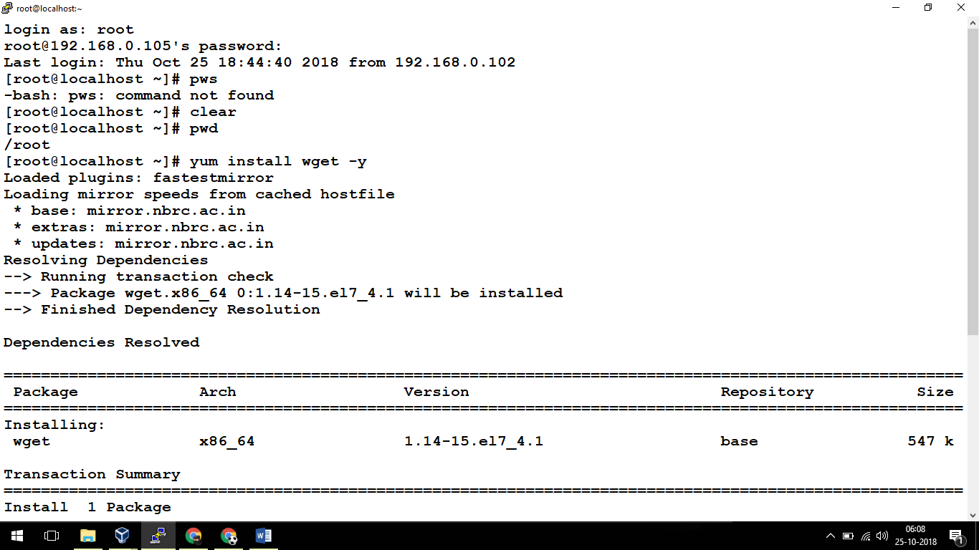

**Used:**

**pwd – to see current directory**

**yum install wget -y**

1. Using **wget & rpm** to install **nano-2.3.1-10.el7.x86_64.rpm**

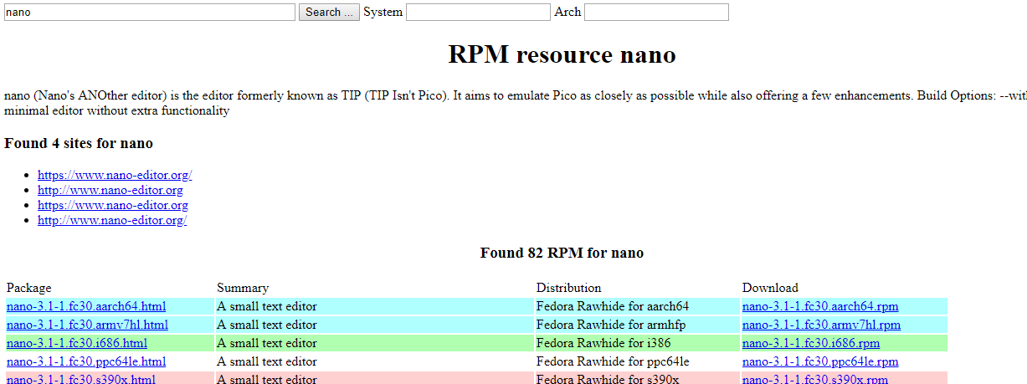

[**https://rpmfind.net/linux/centos/7.5.1804/os/x86_64/Packages/nano-2.3.1-10.el7.x86_64.rpm**](https://rpmfind.net/linux/centos/7.5.1804/os/x86_64/Packages/nano-2.3.1-10.el7.x86_64.rpm)

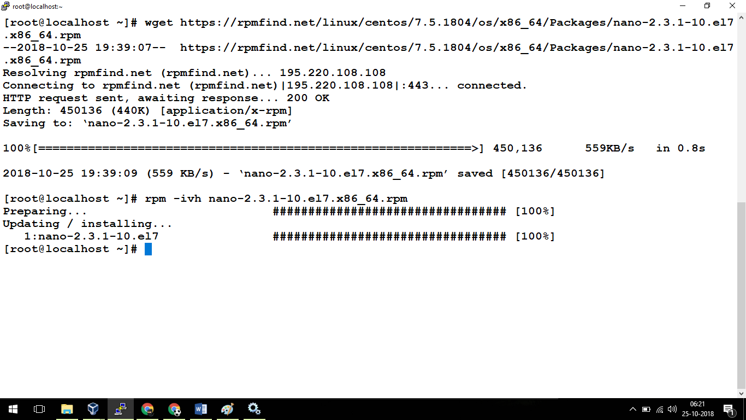

**Used:**

**wget** [**https://rpmfind.net/linux/centos/7.5.1804/os/x86_64/Packages/nano-2.3.1-10.el7.x86_64.rpm**](https://rpmfind.net/linux/centos/7.5.1804/os/x86_64/Packages/nano-2.3.1-10.el7.x86_64.rpm)

**rpm -ivh nano-2.3.1-10.el7.x86_64.rpm**

1. **Man command -** man rpm

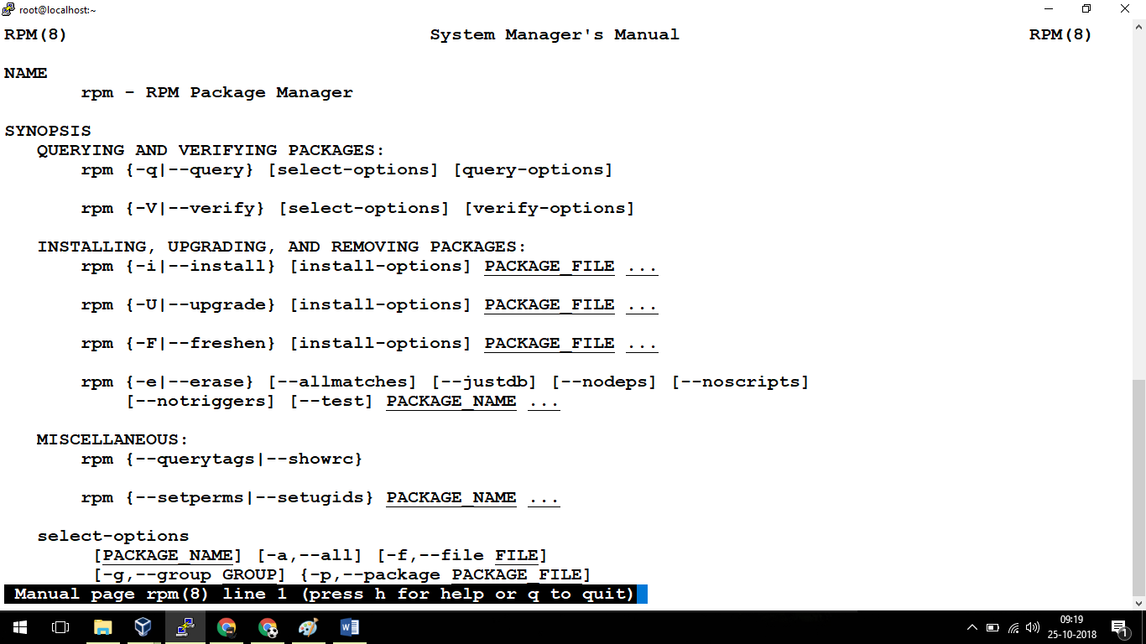

1. **whoami, su, sudo, mkdir, pwd, ls – demo**

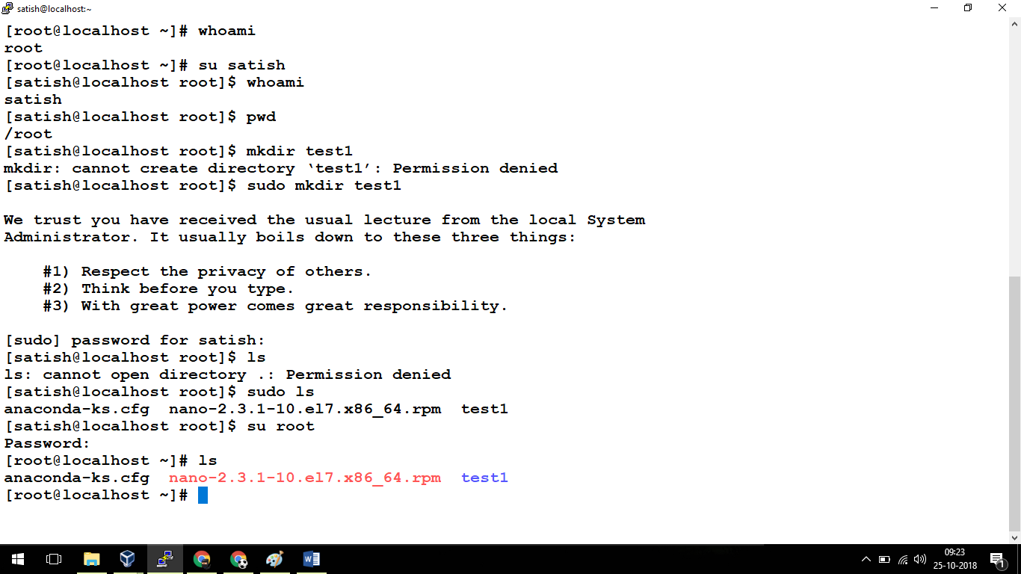

1. **cp, mv, ls, cd, touch, rm**

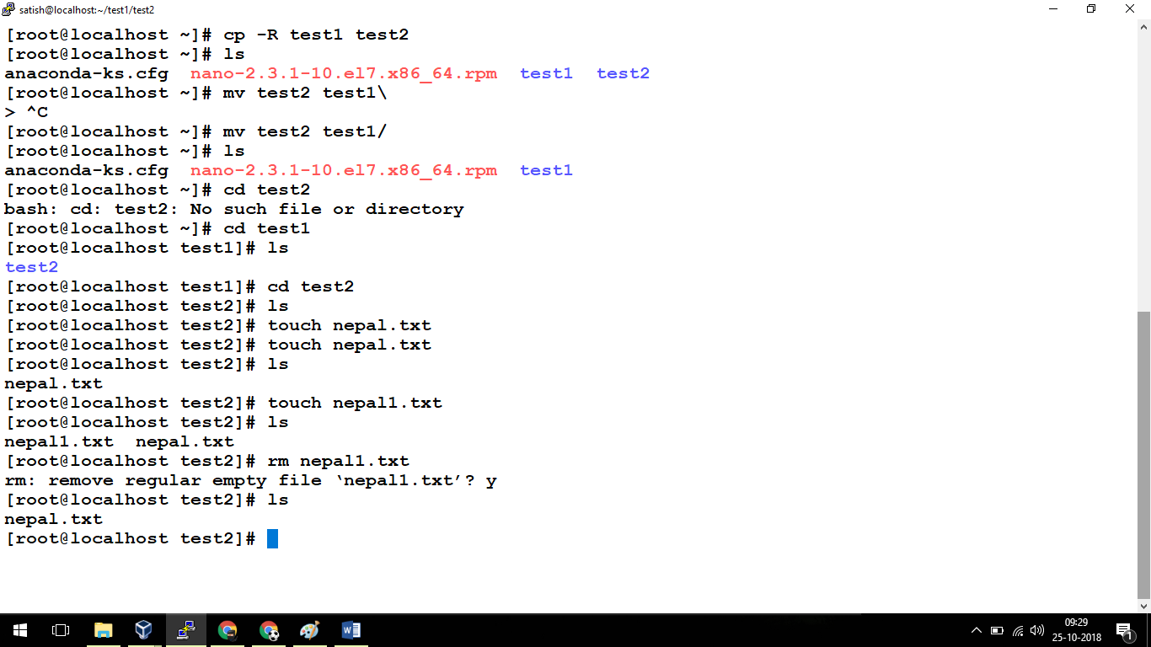

1. **ssh**

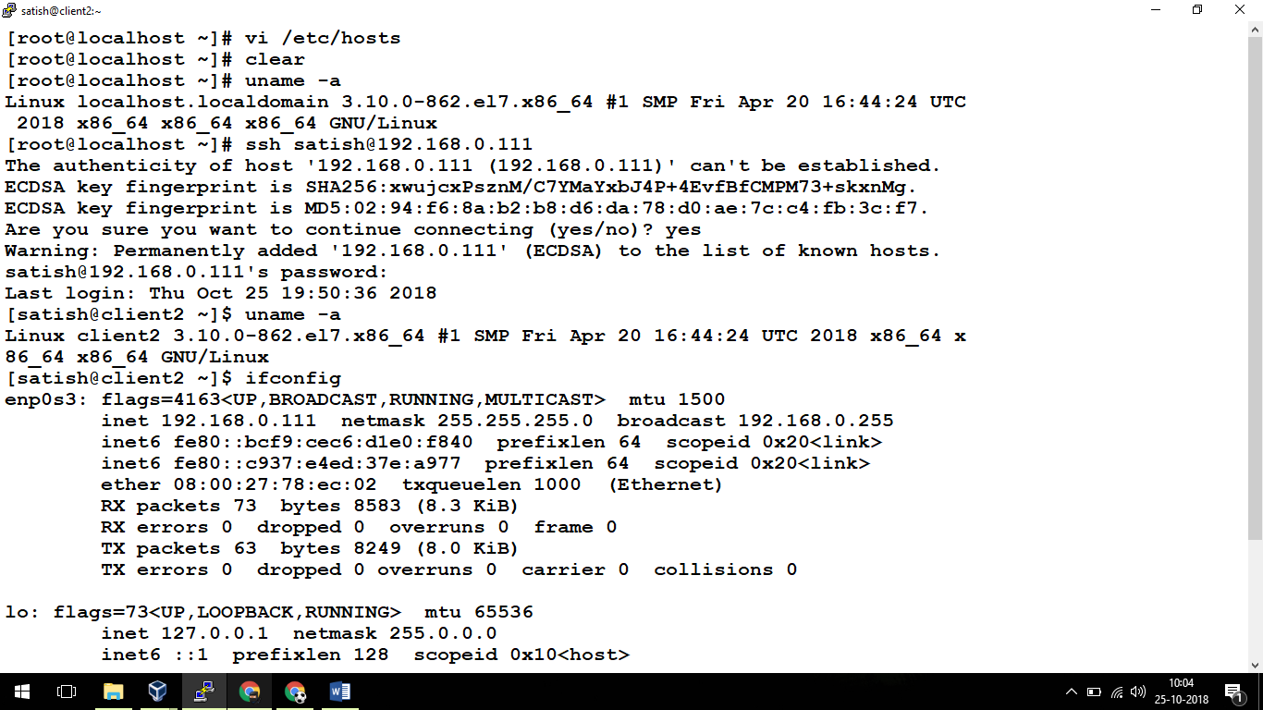

**Assignment 2:**

**Create a file nepal.txt inside folder /root/test1/test2  
include the contenet from https://en.wikipedia.org/wiki/Nepal --- use vi editor**

